**How to Build the Auto Door**

________________________________________________________

Table of Contents:

Mechanical - Page

Considerations Before You Purchase (Pneumatic) - Page

How to Construct the Pneumatic System - Page

Mounting Components - Page

Electrical - Page

How to Safely Deal with Electricity - Page

Understanding the Power Cabinet - Page

Considerations Before You Purchase (Electrical) - Page

How to Wire the Components - Page

How to Wire the Power Cabinet - Page

Code (Ladder Code) - Page

Basic of Ladder Code - Page

Using the Ladder Code Simulator - Page

How to Access the Ladder Code on the CNC (Fanuc Computer Only) - Page

How to Edit the Ladder Code on the CNC (Fanuc Computer Only) - Page

How to Save the Edits in Ladder Code (Fanuc Computer Only) - Page

What Was Added to the Lynx 220L - Page

How to Use it All to Install the Auto Door - Page

Choosing the CNC Relays - Page

Tips and Tricks

5 Pin Relays - Page

Videos, Links, and Other Helpful Resources

—----------------------------------------------------------------------------------------------------------------------------

Mechanical:

**Considerations Before You Purchase (Pneumatic):**

The mechanical side is pretty universal but there are a few things to consider:

1 Orientation of the air cylinder

The air cylinder can either be mounted so that the piston extends to the left or to the right. Depending on which way the air cylinder is mounted, the piston extending could mean either close or open, (and vice versa). For example on the Lynx the air cylinder is mounted on the right of the machine; this means that when the piston extends the door opens. If it were mounted on the left side, door open would be piston retracting. Keep in mind the piston retracts slower than it extends; try to mount the air cylinder so that the door opening is achieved by the piston extending.

2 Obstructions of the light curtain

Certain objects can get in the way of the light curtain and trigger it. For example, a door handle, tool holder, etc.

3 Mounting/orientation of valves

1. According to the instruction manuals valves last longer when orientated a certain way. This is usually upright.
2. Exhaust flow control valves may have enough force to shoot metal shavings resting on surfaces.
3. If less air hose is used then reaction times are faster. Try to mount valves somewhat near the air cylinder.

4 Piston length

Air cylinder pistons only seem to come in even measurements of inches. Alec prefers to have the door open fully so buy a piston that is either exactly the stroke of the door or longer than the stroke of the door. This will put strain on the bump stops so make sure

the bump stops are strong enough to handle some extra force.

5 Force of air cylinder

As pressure increases so does the force the door exhibits. Increase the pressure only as much as needed to move the door quickly; any more pressure will just result in extra wear and tear.

**How to Construct the Pneumatic System:**

(Suggestion: Wire the valves’ solenoids before assembling the pneumatic system.)

Once the initial considerations are done and the parts have been ordered, assemble the pieces according to Figure _. The black lines are air hoses. The ports are labeled in red; the port numbers are engraved on the valves. A larger picture of Figure _ can be found in the [Drive folder.](https://drive.google.com/drive/folders/1FBeYtcosmXvoRLvnY9qgUIk1FHBk1H17)

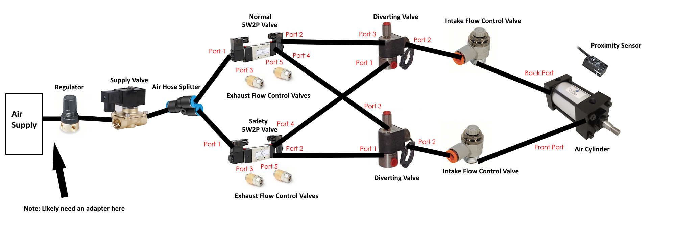

Figure _:

**Mounting:**

| *Component* | *Dimensions (Width x Length)* | *Quantity* |
| --- | --- | --- |
| Supply Valve | TBD | TBD |
| 5W2P Valve | TBD | TBD |
| Diverting Valve | TBD | 4 |
| Pressure Regulator | TBD | TBD |
| Magnetic Proximity Sensor | TBD | TBD |
| Light Curtain (Receiver) | TBD  M4 x ? | 4  4 |
| Light Curtain (Emitter) | TBD (bolts that adjust angle)  TBD (bolts for mounting to machine)  TBD (washers for countersunk bolts) | 4  TBD  TBD |
| Safety Relay | N/A (it is a DIN rail mount) | N/A |

—----------------------------------------------------------------------------------------------------------------------------

Electrical:

**How to Safely Work with Electricity:**

1 Touch the least amount as possible

If the operator is never touching a circuit then the operator can never be shocked. Touch the least amount of components as possible.

2 Advice for testing

If possible, test with power off. Disconnect power, lock out machine, flip circuit breaker

If live testing is needed then take extra precaution, the chances of getting shock are far greater

Never wire connections when the power is on. Whenever wiring, switch terminals, or anything that changes a circuit, always have the power off. The exception is using a multimeter.

3 Avoid extremely cheap equipment

Do not use a $20 multimeter. They do not have the proper safety and can ignite if used incorrectly or exposed to too high of voltage.

1 General Rules:

1. The first time power is turned on after wiring, have a fire extinguisher on hand. The first couple seconds of fires are crucial.
2. There are two levels of voltage in the power cabinet: 220V and 24V. The 220V components are pretty dangerous and labeled with a yellow sign featured in Figure _. For the scope of this manual, never touch these. To be extra safe (a little over the top), maintain at least a two inch gap from them if possible.
3. Do not touch metal with the exception of the power cabinet walls and doors. Only touch plastic, glass, or wire insulation. The power cabinet is designed so that this is easily achievable. 24V is not enough voltage to shock through the plastic, glass, or wire insulation. 220V may shock on rare occasion.
4. Always check the insulation on the wires before plugging into power. Sometimes insulation gets stripped and exposes wire. That wire could very easily shock the user.
5. Short circuits are really the only danger in wiring 24V. It is not always clear whether there will be a short circuit but here is a pretty reliable method: the wires should always be connected to a component.
6. When doing any work in the power cabinet, unless necessary for testing, always turn off the machine and main breaker. NEVER wire or dewire with the power on.
7. If testing on live components is necessary then double check your actions before committing to them.

2 Always double check wiring.

Always.



Figure _:

**Understanding the Power Cabinet:**

1 What are relays?

1. A relay is just a switch. What makes it special is that the switch is flipped electrically, (as opposed to a light switch which is flipped by hand). Observe Figure _ and Figure _.

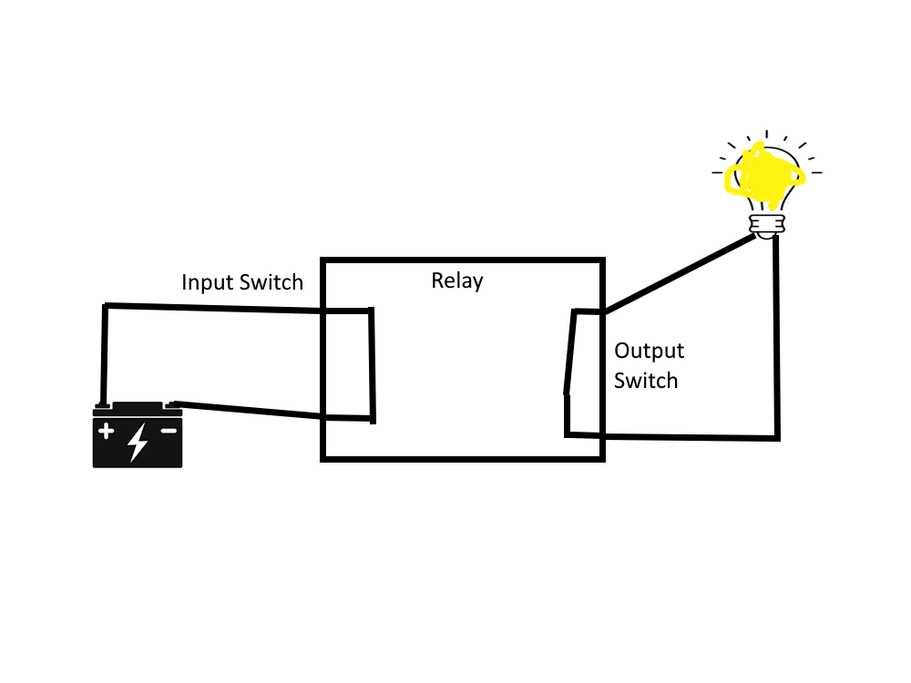

Figure _: Because the battery is connected to the input switch, the input switch is closed. Since the input switch is closed, the output switch is also closed and the lightbulb turns on.

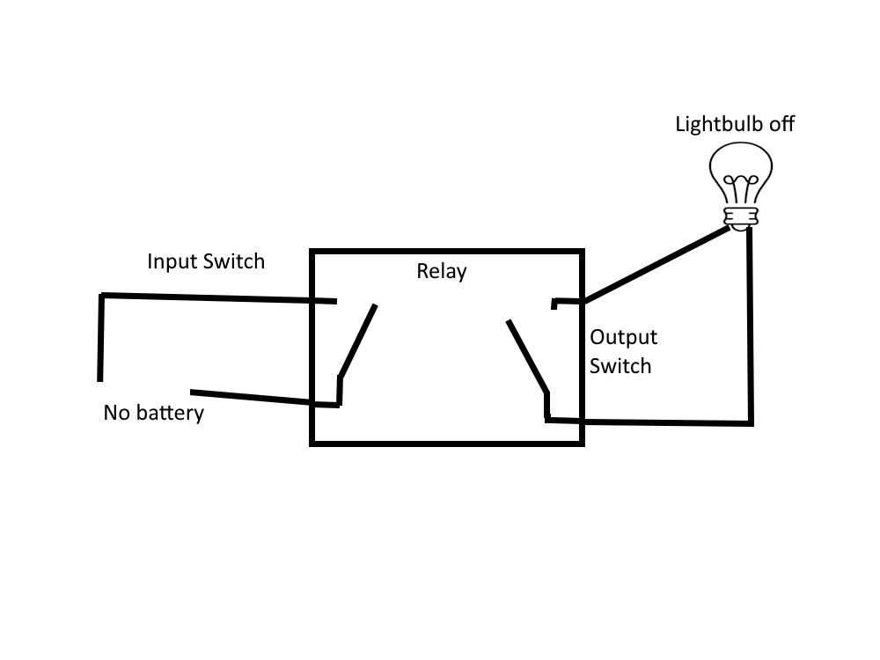

Figure _: Because the battery is *not* connected to the input switch, the input switch is *open*. Since the input switch is *open*, the output switch is also *open* and the lightbulb turns *off*.

1. There are two types of relays in the power cabinet: input and output.

b.1 ) Output relays are controlled by the CNC’s computer. When the ladder code tells the output relay to flip, the

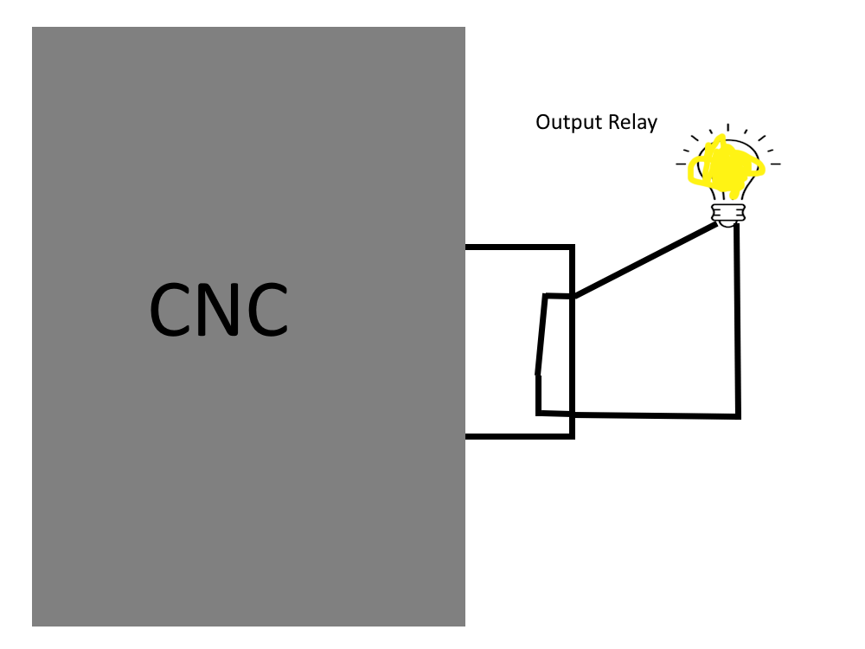

Figure _: When looking in the power cabinet, this is essentially what is seen. The output switch is available and the input switch is inside the CNC.

b.2 ) Input relays do not have power and whatever device is connected to it needs to supply that power. For example, when a sensor is triggered, it will send power through its wires and activate the input relay. When this input relay is triggered, the CNC’s computer will “know” that the sensor has been triggered.

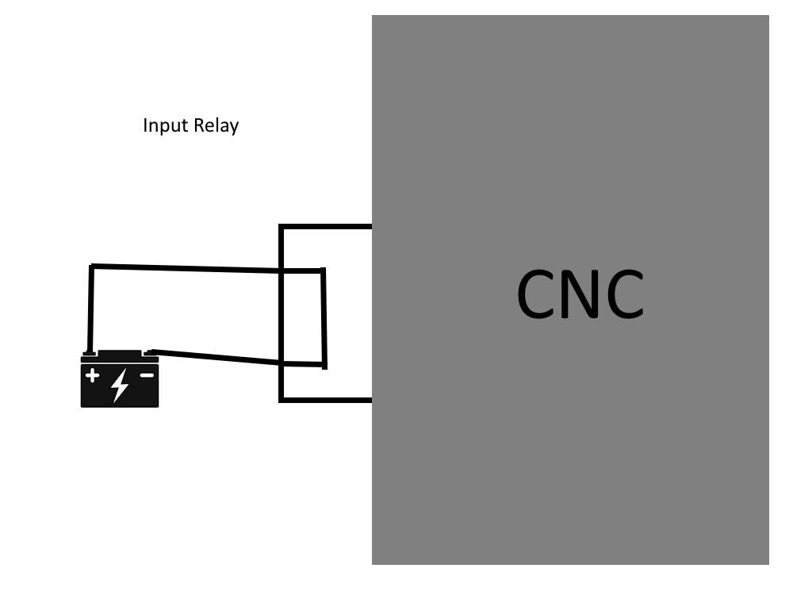

Figure _: When looking in the power cabinet, this is essentially what is seen. The input switch is available and the output switch is inside the CNC.

2 Context

Two pictures will be discussed. Refer to Figure _.

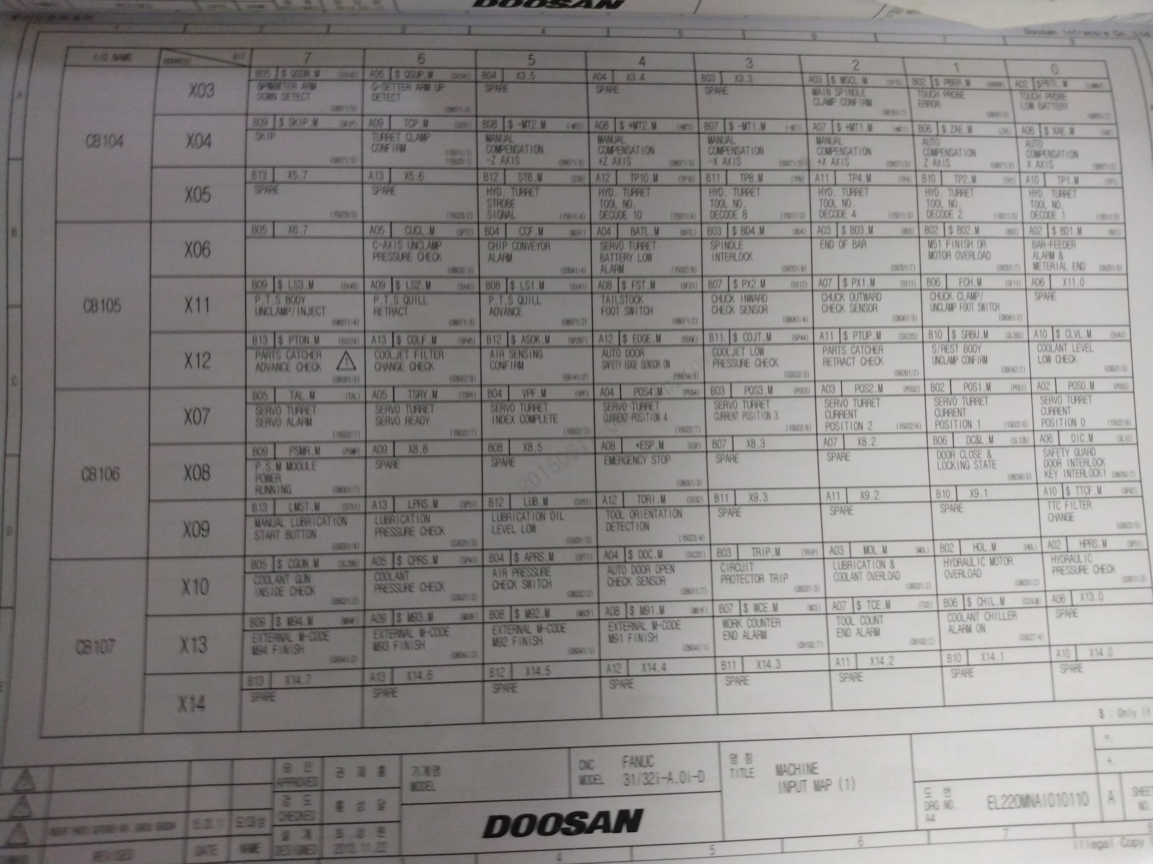

Figure _:

Figure _ is a page from the electrical manual. This table lists relays. The column called “I/O Name” tells you which set of relays, (24V or 5V, input or output). Unfortunately each relay has multiple names and they are not used consistently. This is discussed more in the Ladder Code section.

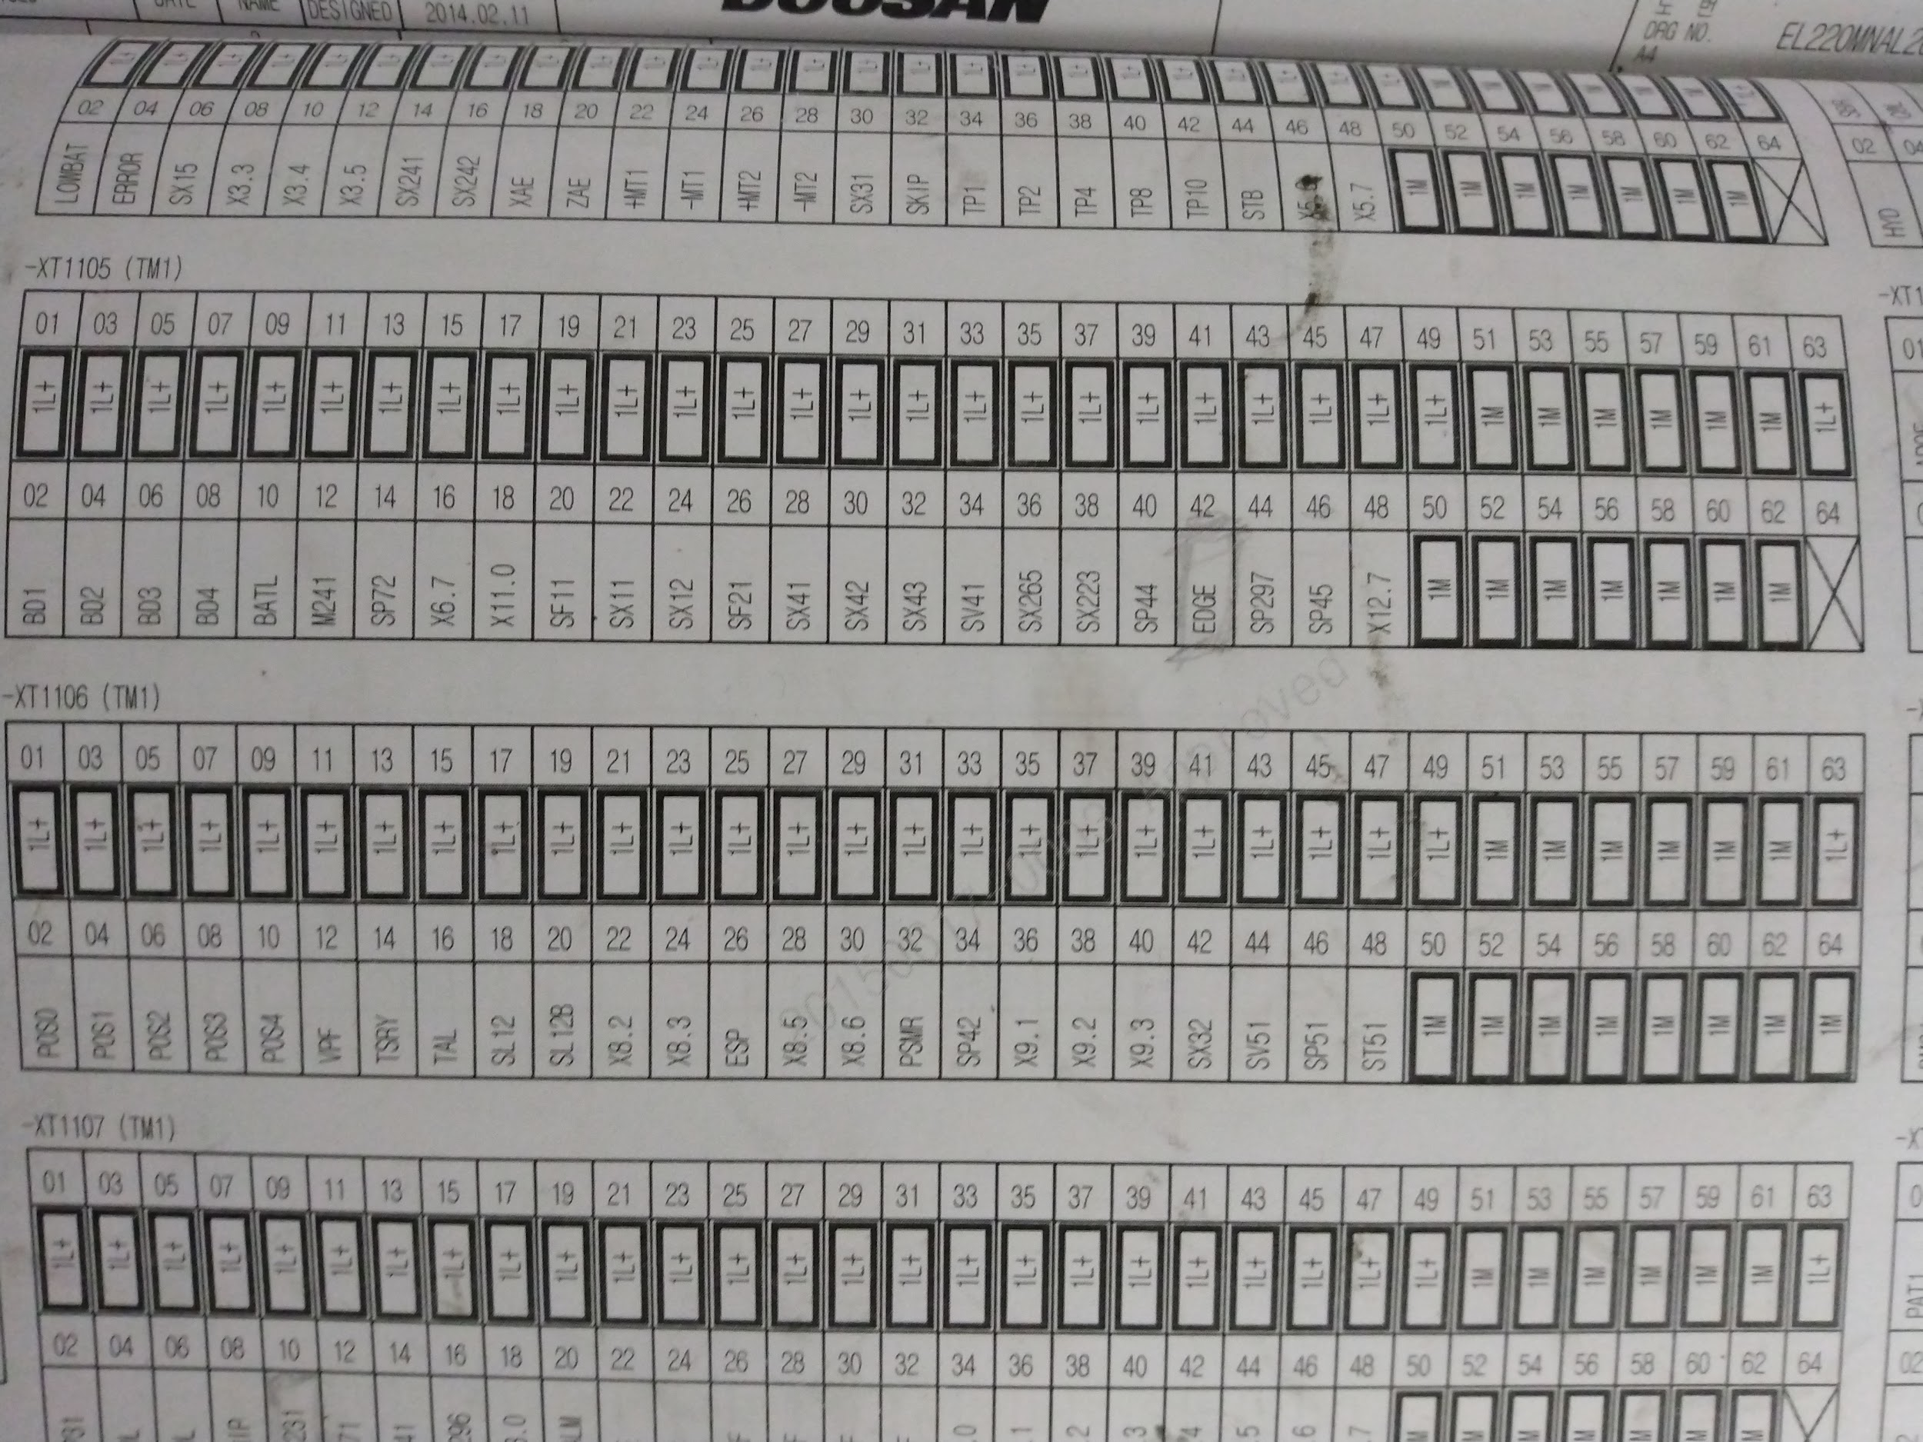

Figure _:

Figure _ is a page from the electrical manual. It shows the relay racks and their individual relays. First, we will discuss the naming of the relay racks. The relay racks are named XT110- (XT1104, XT1105, and so on). “TM1” means input relays and “TM2” means output relays.

Next, notice how each relay is laid out in each rack. Each relay has a name that tells the operator what it does. For example, look at XT1104 TM2; relay 10 is called DOP which is the relay that tells the auto door to open. How does an operator know what DOP does? Refer to Figure _.

Finally, notice how some relays are labeled “1L+” and “1M”. These are NOT relays. “1L+” is a power source, 24V. “1M” is 0V. These are never switched.

1L+ = 24V

1M = 0V

So for example, the supply solenoid, (by design), does not connect to any relays, it just needs to be connected to power. So the 24 Volt Wire will be connected to 1L+ and the 0 Volt Wire will be connected to 1M.

**Considerations Before You Purchase (Electrical):**

1 Determine which CNC relays will be used

Inside the CNC’s electrical manual will be a list of relays and what they do. It is wise to map these so an estimate for the quantity of wire can be made.

**How to Wire the Components:**

*Tools Needed:*

*Tiny flathead screwdriver*

*Heat gun*

*Wire strippers/wire clippers*

*Mutlimeter (if testing)*

*Soldering Iron (Flux and Solder as well)*

*Parts Needed:*

*Butt connectors*

*Heat shrinks*

*Fuse*

*Fuse holder*

Notes:

-Neutral and 0V and 1M and ground, (in this case), mean the same thing.

-Live and 24V and 1L+, (in this case), mean the same thing.

-To simplify, wires that need to be wired to 24V will be called “24 Volt Wire” and wires that need to be placed at 0V, (aka wires that need to be grounded), will be called “0 V Wire.”

1 Wiring a valve’s solenoid (includes 5W2P, diverting, supply)

1. First the basics. All of the valve solenoids will have three wires. One 24 Volt Wire and two 0 Volt Wires. (If you are confused why there are two 0 Volt Wires, it is a safety regulation. dc only technically needs two wires (24 Volt and 0 V) to operate).
2. Find a path through the CNC that will not contact moving parts. Most CNCs have wire trays but those do not have to be used.
3. Measure out the length of wire needed. Try to place the wire as close to the true path as possible, (push into corners, run along the wire keepers in the power cabinet, knowing exactly which terminal the wire is leading to and how much is needed to be securely in the terminal’s grasp, etc.). Also remember that fuses will be installed and so incorporate that extra distance as well. It is always a good idea to leave an extra inch or so.
4. Almost every valve has a DIN connector shown in Figure _. The electrical connections are hidden inside. Start by unscrewing the screw on the top and removing it completely. After removing the DIN connector from the valve, place a flathead screwdriver in a tiny rectangular spot and gently pry the inside piece out of its shell.

You will see three screws. These are the electrical terminals. They are numbered, with Terminal 3 having the bigger prong.

Terminal 1: 24 Volt Wire

Terminal 2: 0 Volt Wire

Terminal 3 (bigger prong): 0 Volt Wire

Give Terminal 3 its own wire; it is not dangerous to bridge it to Terminal 2 but it defeats the purpose of even wiring Terminal 3, aka, having a back up.

Loosen the screws and observe a hole open; this hole is where the wire will be inserted. Strip enough insulation so that there is plenty of contact between the screw of the head, the metal plate in the back, and the wire. Tighten the screw a decent amount, the wire is strong. Run the wires through the circular hole in the DIN connector, reinstall all the parts, and tighten the screw. (It does not matter which direction the DIN connector is facing).

2 Adding a fuse to a valve’s solenoid, (for 5W2P, diverting, supply)

1. Add fuses to the 24 Volt Wire.
2. The fuses and fuse holders bought are automotive. Django chose these because automotive fuses are cheap and easy to obtain. The downside is that the automotive fuses holders have 14 gauge wire which cannot be connected to the 24 gauge wire with a butt connector. Unless fuse holders with 22-24 gauge wire are found, the connections need to be soldered.
3. When inserting a fuse it is always a good idea to check that it is not blown; this will be troubleshooting much easier. To check a fuse, grab a multimeter and find the continuity setting. First, touch the red connector and the black connector together to test the buzzer inside the multimeter; if it beeps then you are good, if not then you need to replace the multimeter. Next, place the red connector on one leg of the fuse and the black connector on the other leg of the fuse. If you hear the multimeter beep, then the fuse is good. If it is silent, the fuse is blown and needs to be replaced. It is a 2 amp automotive fuse you can grab from O'Reillys or Autozone.

3 Magnetic proximity sensor

1. Check if the magnetic proximity sensor’s wires are long enough to reach the terminals in the power cabinet. If not, they need to be extended using butt connectors.
2. The magnetic proximity sensor also has three wires but the situation is slightly different from the valve solenoids.

Brown Wire = 24 Volt Wire

Blue Wire = 0 Volt Wire

Black Wire = goes to CNC relay, (refer to the How to Wire the Power Cabinet section)

4 Adding a fuse to the magnetic proximity sensor

1. Add a fuse to the brown wire. Neither the blue or the black wire need to have fuses.
2. The fuses and fuse holders bought are automotive. Django chose these because automotive fuses are cheap and easy to obtain. The downside is that the automotive fuses holders have 14 gauge wire which cannot be connected to the 24 gauge wire with a butt connector. Unless fuse holders with 22-24 gauge wire are found, the connections need to be soldered.
3. When inserting a fuse it is always a good idea to check that it is not blown; this will be troubleshooting much easier. To check a fuse, grab a multimeter and find the continuity setting. First, touch the red connector and the black connector together to test the buzzer inside the multimeter; if it beeps then you are good, if not then you need to replace the multimeter. Next, place the red connector on one leg of the fuse and the black connector on the other leg of the fuse. If you hear the multimeter beep, then the fuse is good. If it is silent, the fuse is blown and needs to be replaced. It is a 2 amp automotive fuse you can grab from O'Reillys or Autozone.

5 Light curtain ([Instruction Manual](https://info.bannerengineering.com/cs/groups/public/documents/literature/204371.pdf))

**Emitter:**

1. First the basics. The light curtain has two pieces: emitter and receiver. They may have the same color wires but they do different things. Figure _ shows what each wire means.
2. Check if the emitter’s wires are long enough to reach the terminals in the power cabinet. If not, they need to be extended using butt connectors.
3. FOR THE EMITTER, the white and black wires do not do anything. They should be trimmed and covered so that no wire is exposed.
4. The green/yellow wire is the second 0 Volt Wire.

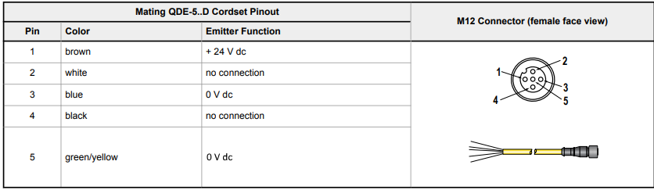

Figure _:

**Receiver:**

1. Refer to Figure _ for which each color means.
2. Check if the receiver’s wires are long enough to reach the terminals in the power cabinet. If not, they need to be extended using butt connectors.
3. FOR THE RECEIVER, the white and black wires are the output for the light curtain. It is very important to note that these outputs cannot be connected to the CNC relays; the light curtain’s outputs must connect to the safety relay. Then the safety relay’s outputs connect to the CNC relays. This is explained more in the safety relay section.
4. The green/yellow wire is the second 0 Volt Wire.

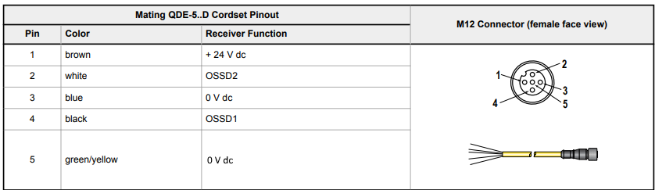

Figure _:

6 Safety Relay ([Instruction Manual](https://info.bannerengineering.com/cs/groups/public/documents/literature/141249.pdf))

Wiring

1. Measure out the length of wire needed. Try to place the wire as close to the true path as possible, (push into corners, run along the wire keepers in the power cabinet, knowing exactly which terminal the wire is leading to and how much is needed to be securely in the terminal’s grasp, etc.). Also remember that fuses will be installed and so incorporate that extra distance as well. It is always a good idea to leave an extra inch or so.

If possible run the light curtain cables away from other cables. This reduces electrical interference and improves light curtain performance.

1. This safety relay uses screw terminals just like the DIN connectors on the valve solenoids. Make sure there is enough metal to metal contact between the wire and the terminals. Remember to consider fuses. Refer to Figure _ for the wiring.

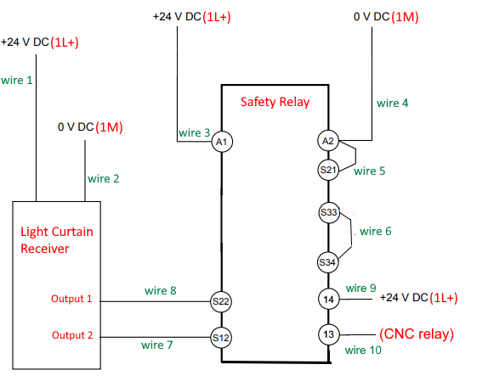

Figure _:

Each connection will be explained here:

wire 1: This is brown wire in the light curtain receiver bundle. It needs to be wired to any 1L+ terminal on the CNC.

wire 2: This is the blue wire in the light curtain receiver bundle. One side needs to be wired to any 1M terminal on the CNC.

wire 3: This is a wire that needs to be cut from the spool. One side needs to be wired to any 1L+ terminal on the CNC. The other side connects to the A1 terminal on the safety relay.

wire 4: This is a wire that needs to be cut from the spool. One side needs to be wired to any 1M terminal on the CNC. The other side connects to A2 terminal on the safety relay.

wire 5: This is a wire that needs to be cut from the spool. One side needs to be wired to the A2 terminal. The other side needs to be wired to the A21 terminal. (If it feels like this would make a short circuit, good thinking, normally that would be correct. In this case the engineers designed around this).

wire 6: This is a wire that needs to be cut from the spool. One side needs to be wired to the S33 terminal. The other side needs to be wired to the S34 terminal. (If it feels like this would make a short circuit, good thinking, normally that would be correct. In this case the engineers designed around this).

wire 7: This is white wire in the light curtain receiver bundle. It needs to be wired to the S12 terminal.

wire 8: This is black wire in the light curtain receiver bundle. It needs to be wired to the S22 terminal.

wire 9: This is a wire that needs to be cut from the spool. One side needs to be wired to any 1L+ terminal on the CNC. The other side connects to the 14 terminal.

wire 10: This is a wire that needs to be cut from the spool. One side needs to be wired to the EDGE CNC relay. The other side connects to the 13 terminal.

The safety relay has a green LED to indicate power.

The safety relay has two green LEDs; each represents one output.

Fuses

Wires that need fuses:

wire 1

wire 3

wire 9

**How to Wire the Power Cabinet:**

Make sure to have read the Understanding the Power Cabinet section.

Make sure to have read the Ladder Code section.

Make sure to have read the How to Safely Deal with Electricity (seriously do it, I made it as painless as possible so just read it)

Pictures of each wiring diagram are in the Drive folder if a large version is needed

*Tools Needed:*

*FIRE EXTINGUISHER*

*Small Flathead Screwdriver*

*Angled Pick*

*Needle Nose Pliers*

1 Prepare the power cabinet

Turn off power to the CNC using the main switch. Turn off circuit breaker for the CNC. Wait 20-30 minutes.

2 Mechanics

1. Inspect wires for stripped insulation. Seriously. Exposed wire could shock you, even if it is a sliver.
2. Label the wires with a label maker. This step does not have to be done now but it will be much faster if done before.  
   Route the wires through a casing hole, usually covered with a rubber plug. Avoid letting the metal of each wire touch anything other than the power cabinet casing. Likely nothing will happen but it is a good practice.
3. The DIN rail has two holes per relay. The bigger hole is where the wire goes, (it will be referred to as a relay terminal from now on). The smaller hole is where pressure is applied to open the bigger hole, (it will be named opener hole). Insert either the screwdriver or pick into the opener hole and rotate the tool away from the relay terminal. It takes a surprising amount of force and slips frequently. BE CAREFUL TO NOT ANGLE YOUR ARM INTO A 220V COMPONENT WHEN GETTING FRUSTRATED WITH THE OPENER HOLE. Once the relay terminal has grabbed the wire, give a gentle tug to make sure the wire does not come out. Use a ziptie to bunch the wires for organization.

2 Supply solenoid

The supply solenoid will have three wires. One 24 Volt Wire and two 0 Volt Wires. Attach the 24 Volt Wire to any 1L+ terminal. Attach the 0 Volt Wires to any 1M terminals, (could be the same terminal or two different). Double check connections.

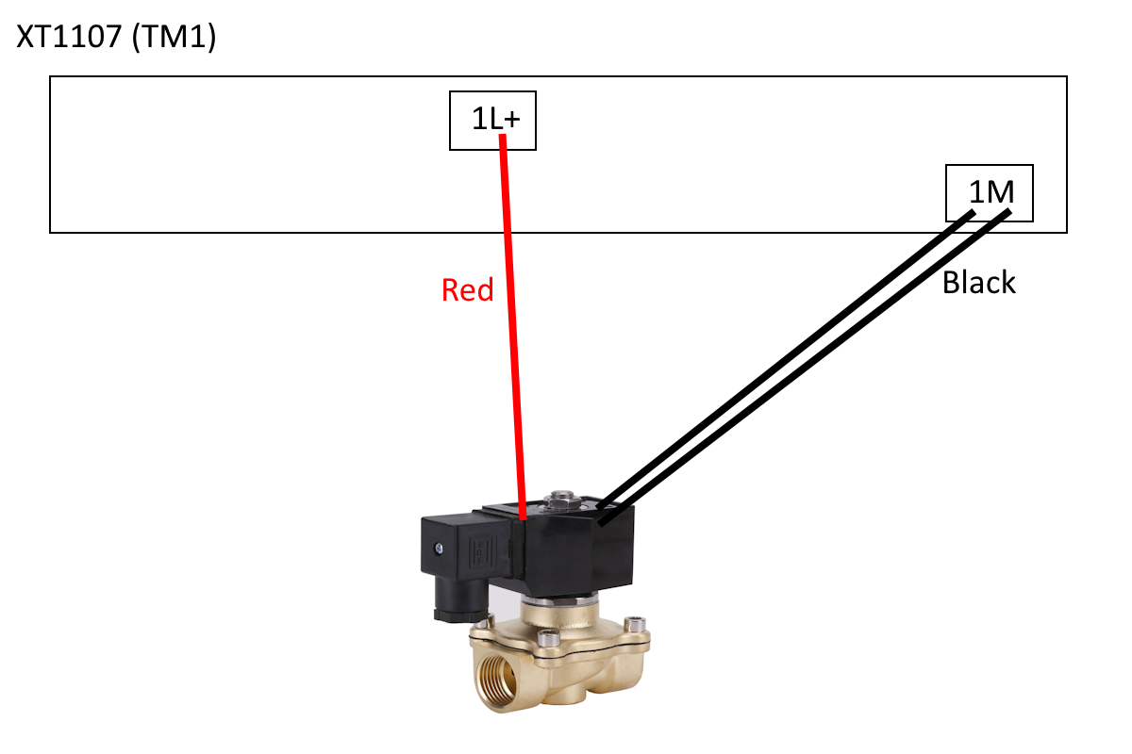

3 Normal 5W2P

The normal 5W2P valve will have 6 wires total. Two sets of one 24 Volt Wire and two 0 Volt Wires. Attach the 24 Volt Wire to the appropriate relay terminal. Attach the 0 Volt Wires to any 1M terminals, (could be the same terminal or two different). Double check connections.

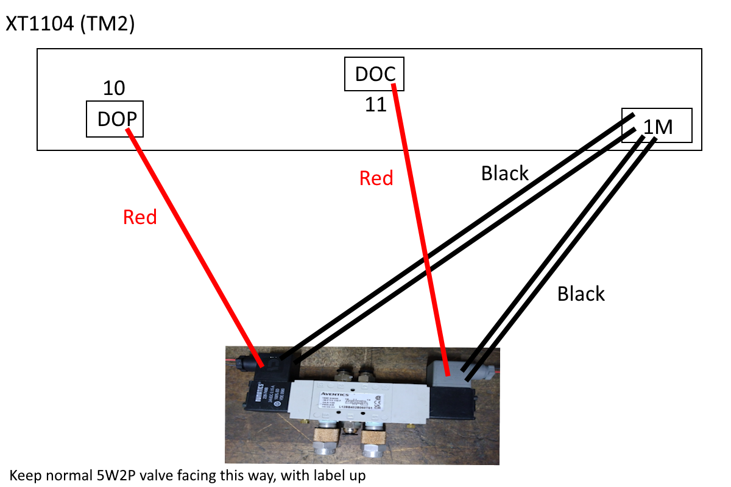

4 Safety 5W2P

The safety 5W2P valve will have 3 wires total. One 24 Volt Wire and two 0 Volt Wires. Attach the 24 Volt Wire to the appropriate relay terminal. Attach the 0 Volt Wires to any 1M terminals, (could be the same terminal or two different). Double check connections.

5 Diverting Valves

Each diverting valve will have two wires total. One 24 Volt Wire and one 0 Volt Wire. Attach the 24 Volt Wire to the appropriate relay terminal. Attach the 0 Volt Wire to any 1M terminal. Double check connections.

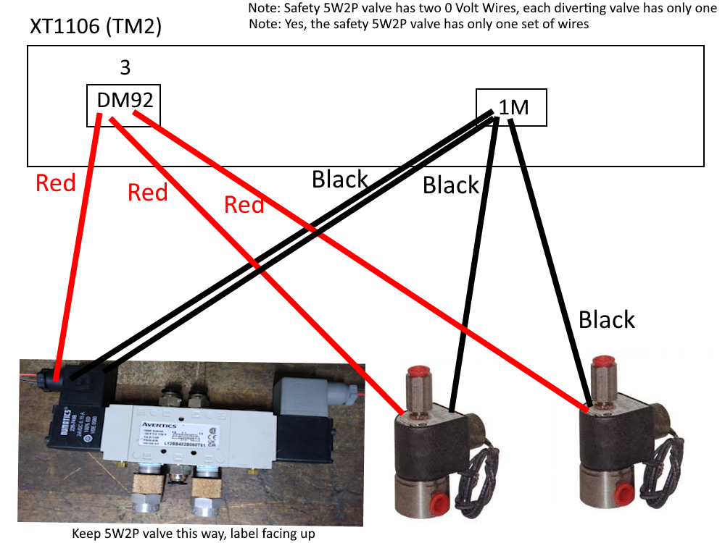

6 Magnetic Proximity Sensor

The magnetic proximity sensor will have three wires total. One 24 Volt Wire, one 0 Volt Wire, and one output wire. Attach the 24 Volt Wire (brown) to any 1L+ terminal. Attach the 0 Volt Wire (blue) to any 1M terminal. Attach the output wire (black) to the appropriate relay terminal. Double check connections.

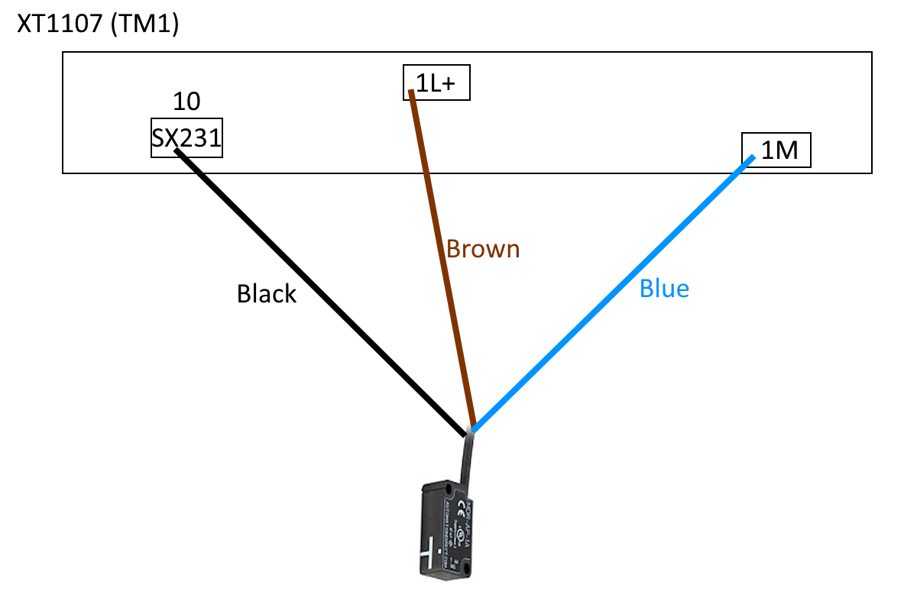

7 Light Curtain Emitter

The light curtain emitter will have two wires total. One 24 Volt Wire and two 0 Volt Wires. Attach the 24 Volt Wire to any 1L+ terminal. Attach the 0 Volt Wires to any 1M terminals, (could be the same terminal or two different). Double check connections.

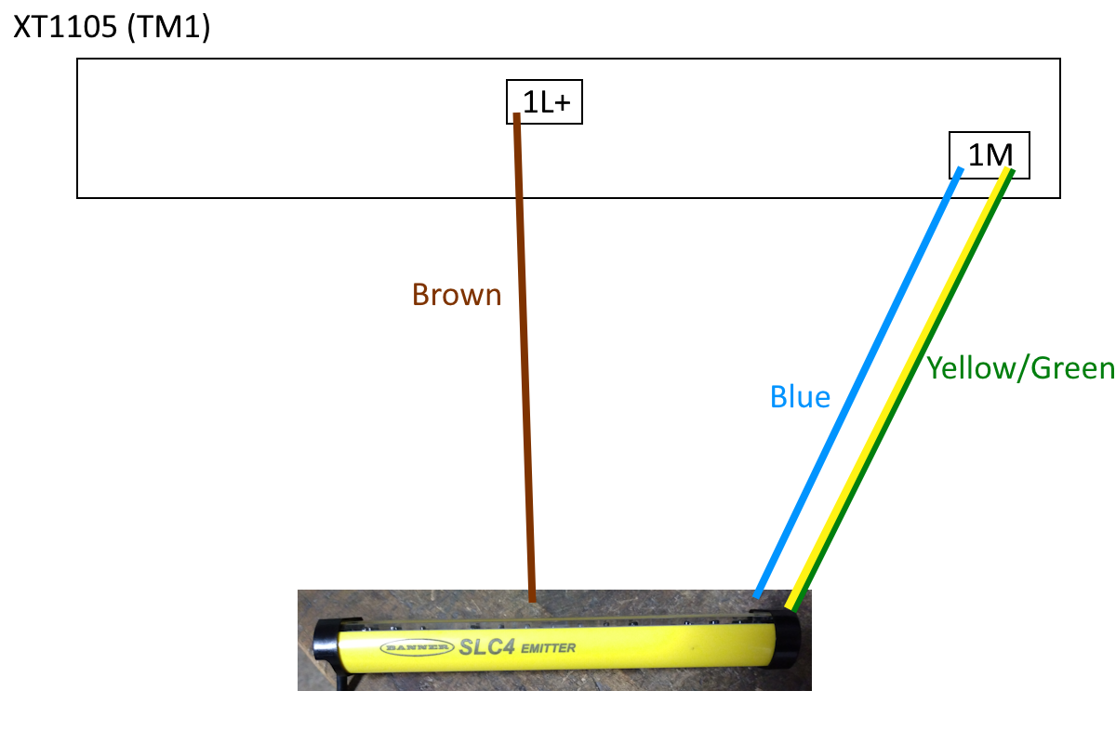

8 Light Curtain Receiver

The light curtain receiver will have five wires total. One 24 Volt Wire, two 0 Volt Wires, and two output wires. Attach the 24 Volt Wire to any 1L+ terminal. Attach the 0 Volt Wires to any 1M terminals, (could be the same terminal or two different). Attach the white output wire to the S12 terminal on the safety relay. Attach the black output wire to the S22 terminal on the safety relay. NEITHER OF THE OUTPUT WIRES SHOULD BE ATTACHED DIRECTLY TO THE CNC. Double check connections.

9 Safety Relay

The safety relay should have four wires, (that need attachment to the CNC). Two 24 Volt Wires, one 0 Volt wire, and one output wire. Attach the 24 Volt Wires to any 1L+ terminal, (could be the same terminal or two different). Attach the 24 Volt Wire to any 1L+ terminal. Attach the output wire, (wire from the safety relay’s Terminal 14), to the appropriate relay terminal. Double check connections.

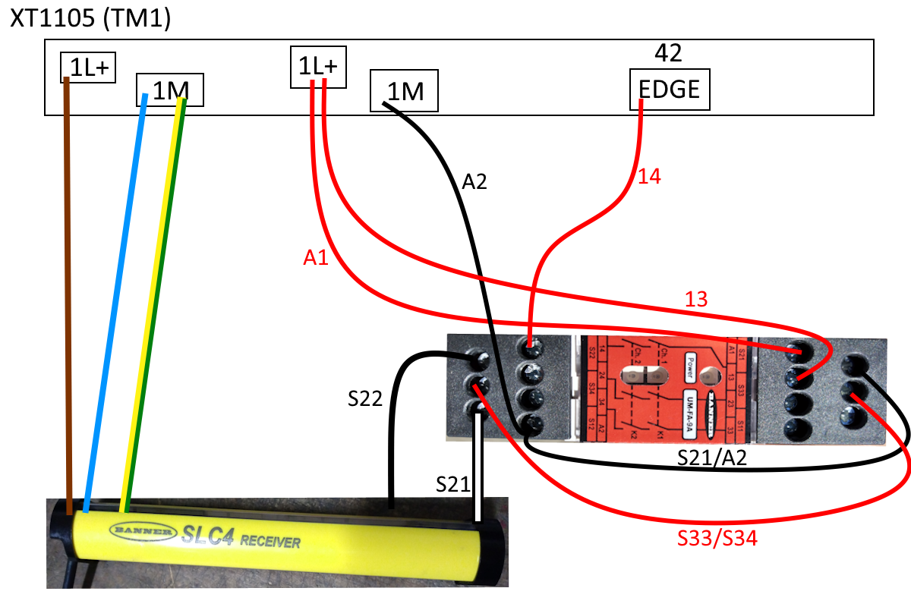

—----------------------------------------------------------------------------------------------------------------------------

Code (Ladder Code):

Ladder code, code, program, and software are all the same thing. It will be referred to only as ladder code for this document.

**Basics of Ladder Code:**

**Using the Ladder Code Simulator:**

This [simulator](https://app.plcsimulator.online/) is kind of funky.

1 In order to add a contact click on “Add new variable” in the bottom left corner and type in the name. Do not change Bool. Once you hit submit it should appear on the list above.

2 Click on the normally open icon near the top right. It should appear on a rung; click and hold to move it with the mouse. Click on it again and select “Select…” to choose the name for it.

3 Click the box with a hat icon to add a rung to the existing run

4 Click the rung icon to add an entirely new rung

5 Click on the green triangle to begin the simulation. Click on each contact to make it either closed or open. When the output contact is green then electricity is flowing to it.

**How to Access/Search the Ladder Code on the CNC (Fanuc Computer Only):**

1. To access ladder code:

a.1) Press the SYSTEM button on the keyboard, top right

a.2) Press the right arrow button right below the screen until PMC LADDER appears on the screen

a.3) Press the blank button right under where it says PMC LADDER

1. To search for contacts:

b.1) Press blank button under LADDER

b.2) Press the blank button under (OPRT)

b.3) Press the blank button under SEARCH MENU

b.4) Type in the name of the contact

b.5) Press the blank button under SEARCH

b.6) Press the blank button under NEXT to go to the next instance and press the blank button under PREV to go to the previous instance.

b.7) If there is an option for LOCAL, press the blank button under it to switch to GLOBAL. (This reduces where the computer will look. Local only searches sections around where you are looking, global searches the entire ladder code).

**How to Edit, (and Save), the Ladder Code on the CNC (Fanuc Computer Only):**

1. Initial reminder, make sure to turn off edit settings so no one accidentally changes the ladder code.

a.1) Press the SYSTEM button on the keyboard, top right

a.2) Press the right arrow button right below the screen until PMC CONFIG appears on the screen

a.3) Press the blank button right under where it says PMC CONFIG

a.4) Press the button under SETING

a.5) Use the arrow keys to move the light blue bow from NO to YES. Switch EDIT ENABLE to YES, switch PROGRAMMER ENABLE to YES. At this point whatever changes made to the ladder code will be lost when the machine is turned off. If permanent changes are to be made, switch WRITE TO F-ROM(EDIT) to YES.

a.6) Press the SYSTEM button again to back out.

a.7) Press the right arrow button right below the screen until PMC LADDER appears on the screen

a.8) Press the blank button right under where it says PMC LADDER

a.9) Press the blank button under EDIT.

a.10) After finding the rung that is to be changed, press the blank button under ZOOM.

a.11) After finishing, press the right arrow key button. To back out of editing with nothing changed, press the blank button under CANCEL EDIT. To save changes, press the blank button under EXIT ZOOM.

a.12) To save a change made, press the right arrow key until CANCEL EDIT and EXIT EDIT appear. Press the blank button under EXIT EDIT and the question, “PMC RUNNING. DO YOU UPDATE PROGRAM?”. Pressing YES will save the change temporarily. It will then ask, “SAVE TO FLASH ROM?”. Pressing YES again will permanently save the changes.

a.13) VERY IMPORTANT. Make sure to set EDIT ENABLE, PROGRAMMER ENABLE, and WRITE TO F-ROM(EDIT) back to NO so no one accidentally changes the ladder code. CATASTROPHIC FAILURE COULD OCCUR IF USER FAILS TO PERFORM THIS STEP.

**What Was Changed in the Lynx 220L:**

Three changes were made to the Lynx 220L

1. KEDGE in the CLINT rung was deleted. Observe Figure _.

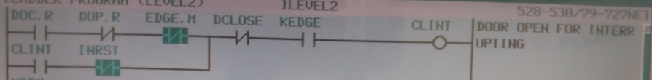

Figure _:

1. A new run below the CLINT rung was added. It had a normally open bit contact named CLINT and a output relay contact named M92.R, (which connects to the M92 output relay.
2. Every instance of M92.R was deleted in order to have no interference with the safety system’s operation.

**Understanding the Ladder Code on the Lynx:**

Refer to Figure _. (The states of the contacts in following photos are not relevant to what is written here. Pay attention only to the structure and order of the contacts, not which ones happen to be actuated in these photos).

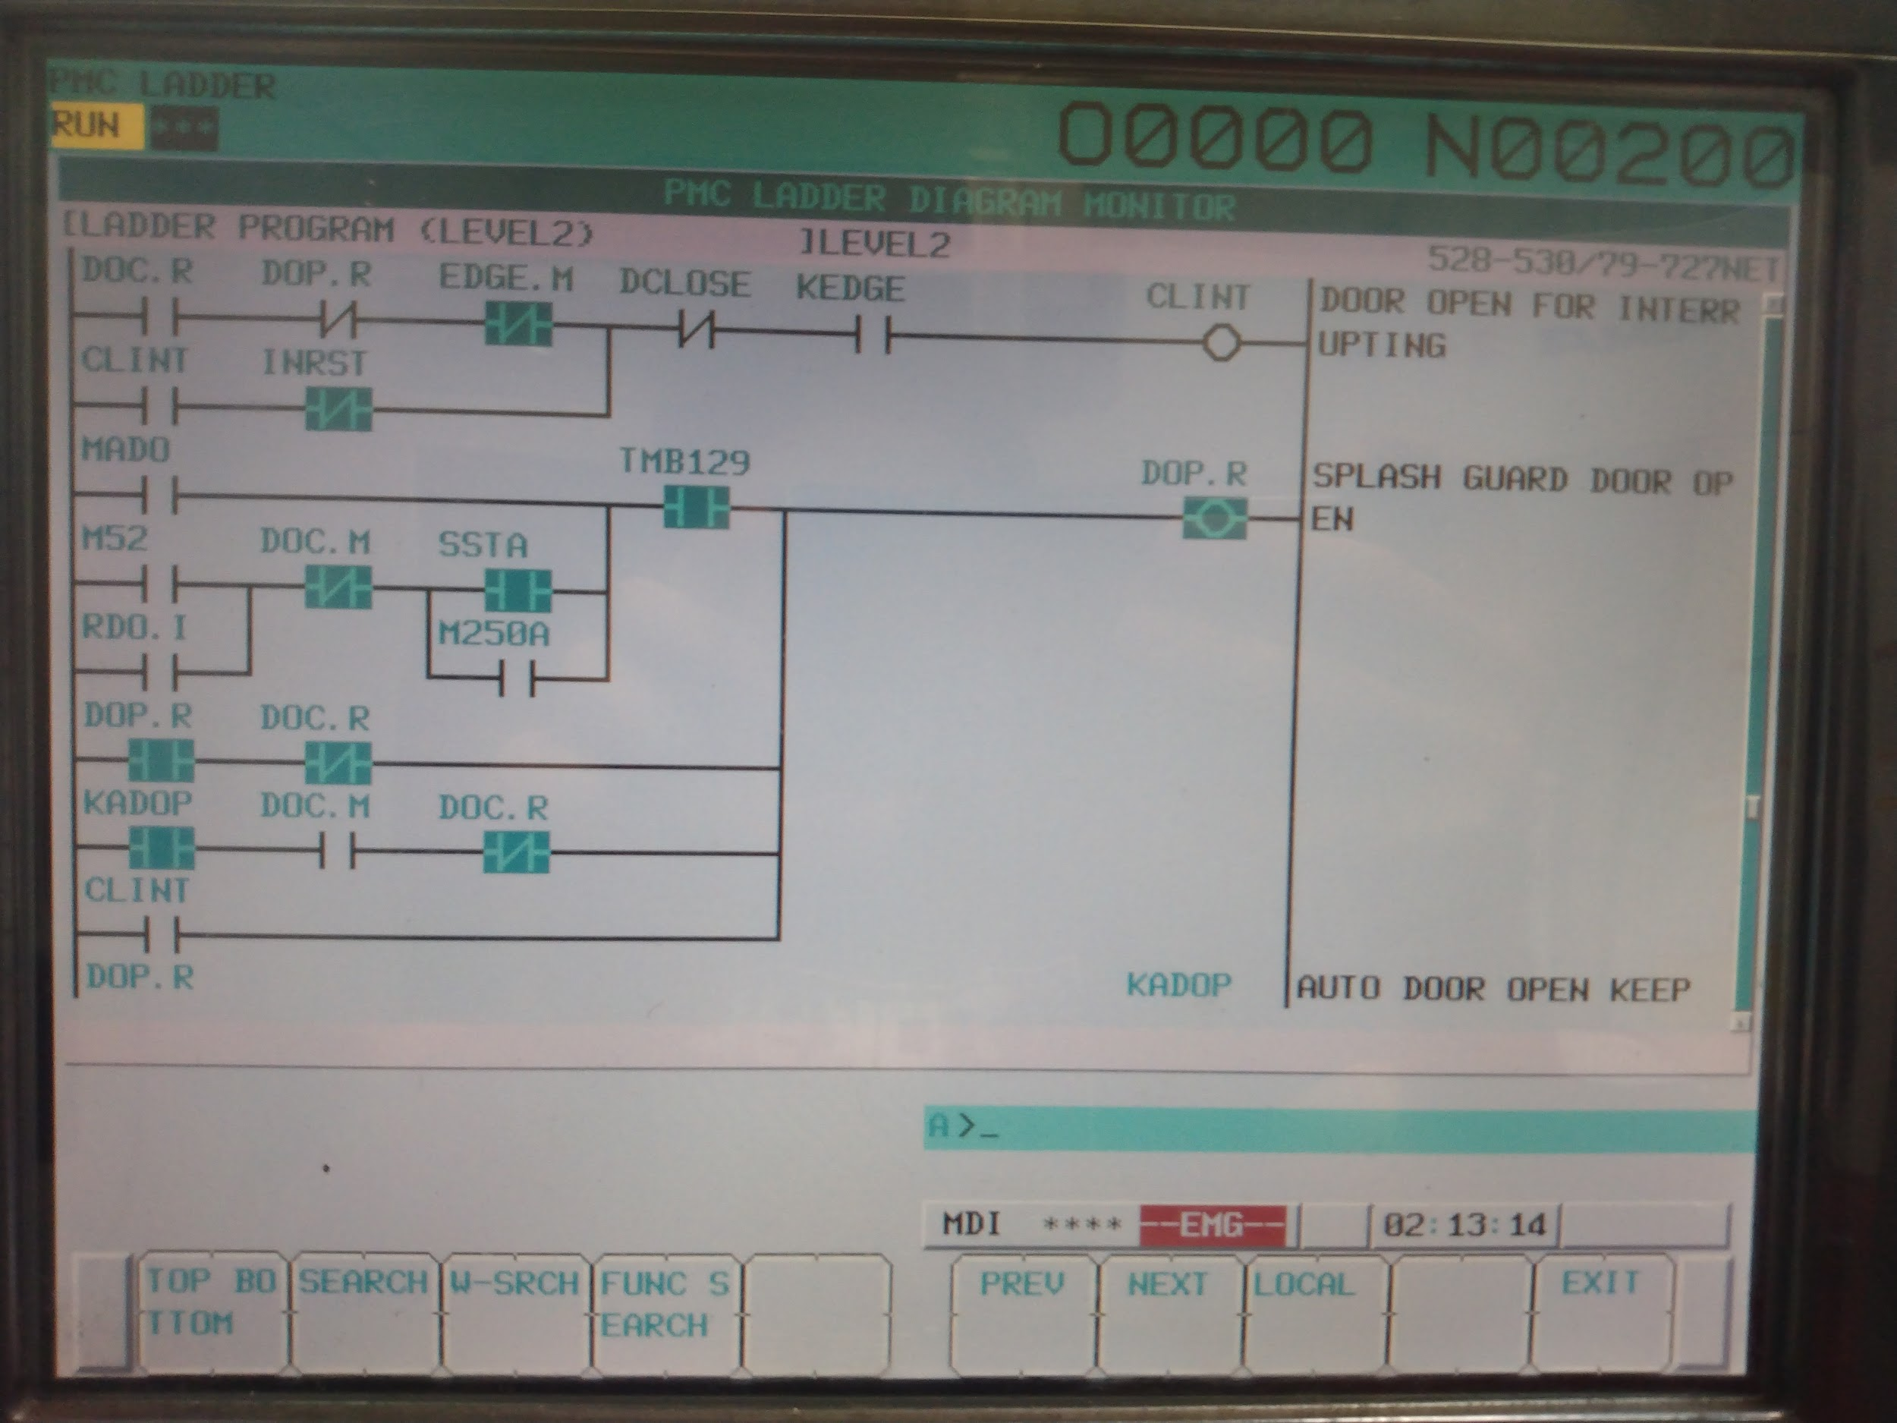

Figure _:

The output relay is the most important part of a rung because the output is what we are trying to send electricity to. In this case we have CLINT as the output relay. CLINT stands for CLose door INTerrupt. Let us examine the two rungs. (All of the sensors used are normally open sensors.)

First Rung:

1. DOC.R. Checking the manual we see that DOC.R is an output relay, (labeled under Y01 and Y means output). The manual also calls it “AUTO DOOR CLOSE.” Putting these two together we can say this; DOC.R is a relay that will send electricity to the 5W2P valve and make the auto door close. Keep in mind, DOC comes from DOor Close and “.R” means Relay.
2. DOP.R. Following the same process we conclude that DOP.R is an output relay that opens the auto door.
3. EDGE.M. Checking the manual we see that EDGE.M is an input relay, (labeled under X12 and X means input). It is also called “AUTO DOOR SAFETY EDGE SENSOR ON.” We can say this: EDGE.M needs a sensor to be connected to it, a sensor that can tell the CNC when the safety system has been triggered.
4. DCLOSE. Checking the manual we do not find a DCLOSE anywhere. Searching the ladder code we find something out. Refer to Figure _.

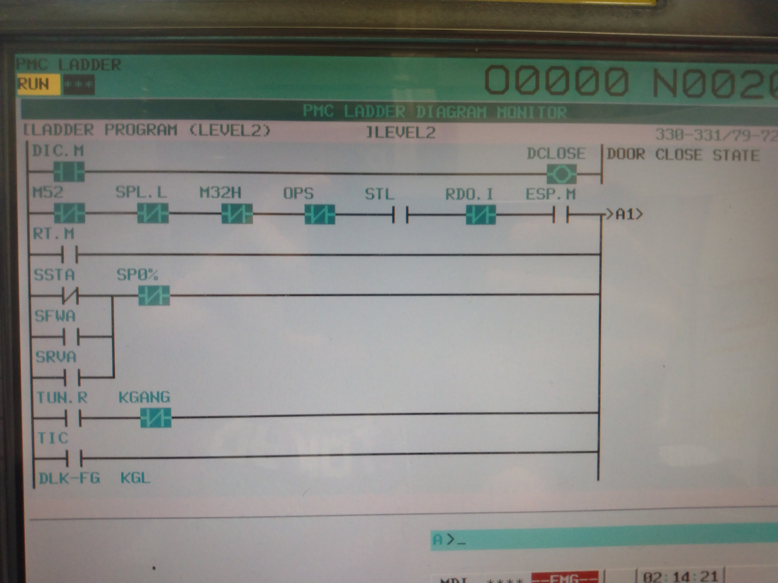

Figure _:

We see that DIC.M is an input for DCLOSE. Looking through the manual we see that DIC.M is there. It is an input and is named “SAFETY GUARD DOOR INTERLOCK KEY INTERLOCK1.” It is not terribly obvious what that means but an interlock keeps the door locked when the machine is running. This means that this relay tells the CNC when the door is closed. (We can test this by pulling the metal piece out of the sensor and watching DIC.M turn on and off, (blue and not blue)). Another interesting note is that DCLOSE is basically just DIC.M because they are the same contact with no other contacts. When DIC.M is closed, so is DCLOSE. When DIC.M is open, so is DCLOSE. So technically DCLOSE is not necessary, (kind of but that is a different topic). So we can say this: DCLOSE is essentially DIC.M which is an input relay that needs a sensor that “tells” the CNC when the door is closed.

1. KEDGE. (This was deleted from the Lynx 220L’s code but it may appear on other machines). KEDGE corresponds to a keep relay. Keep relays are relays that are designed to be either on or off for long periods of time. The Fanuc I Series uses them for settings. KEDGE in this case is a keep relay that tells the machine to either allow CLINT to be activated or not. (It was deleted from the Lynx 220L because Django is not sure why you would ever want to shut off the safety system).
2. Notice how some of the contacts are normally open while others are normally closed. Why? Let us examine each contact individually to understand. Before starting, remember the whole goal of this code is to open the door if the safety system is triggered.

f.1) DOC.R means close the door. Obviously there is no need to interrupt the door if it is not even closing in the first place so this must be actuated (blue). In this case the output relay behaves like normally open. When the door is not supposed to be opened, no electricity. When it is, send electricity. This means we want a normally open contact.

But wait, is this even needed? If DOC.R will tell us if the door is closing then why do we need to check if the door is *not* opening?

f.2) DOP.R means open the door. Well, DOP.R and DOC.R are opposites. So if DOC.R requires a normally open contact then DOP.R would need a normally closed contact.

f.3) EDGE.M is normally closed for safety reasons. If the power goes out, then the voltage drops to 0V, the EDGE.M is actuated. If the light curtain fails, voltage drops to 0V, EDGE.M is actuated.

f.4) Remember that DCLOSE is exactly the same as DIC.M. DIC.M tells the machine that the door is closed. Obviously if the door is already closed then how could it be interrupted? So this needs to be a normally closed contact. (This one seems kind of dumb but it is actually doing is asking if the door is even open in the first place).

**Table of Contacts (Lynx 220L):**

| *Contact Name* | *Type* | *Purpose* |
| --- | --- | --- |
| CLINT | Bit | Stops the door from closing. Used for the safety system, (likely light curtain/safety relay). |
| DOC.R | Output Relay | Sends electricity to the normal 5W2P valve to close the door |
| DOP.R | Output Relay | Sends electricity to the normal 5W2P valve to close the door |
| EDGE.M | Input Relay | Allows the safety system, (likely light curtain/safety relay), to tell the CNC when something is in the door’s way |
| DIC.M (DCLOSE) | Input Relay | Tells the CNC that the door is closed |
| INRST | Bit | Allows the safety system to be reset and the system to return to normalcy. |
| RST | Button | The actual reset button on the CNC machine. On the Lynx the button is called “ALARM RESET EMG. RELEASE” |
| ARST | Bit | Essentially the same as RST. (RST is the actual button. There are multiple bits made from RST, all designed for the specific scenario they are used). |
| TMB129 | Timer | Unsure. Something to do with the door interlock |
| MADO | Unsure | Unsure |
| M52 | Bit | The contact for the M52 command in M-code. This a connection between ladder code and M-code. |
| SSTA | Input (not relay, from computer) | Tells the machine that the spinning parts (chuck for example) have stopped |
| RDO.I | Unsure | Unsure. Something to do with a cobot |
| M250A | Unsure (likely bit or keep relay) | This is a maintenance feature. It allows the machine to do anything under any conditions. |
| KADOP | Bit | Keeps DOP.R triggered which keeps the door open |
| MADC | Unsure | Unsure |
| M53 | Bit | The contact for the M53 command in M-code. This a connection between ladder code and M-code. |
| RDC.I | Unsure | Unsure. Something to do with a cobot |
| ONLINE | Unsure | Unsure. Something to do with a cobot |
| KADCL | Bit | Keeps DOC.R triggered which keeps the door closed |
| FLC | Bit | Code to flash button lights on and off. Not really important at all. |
| ADOP.L | Output (not relay, from computer) | The light for the auto door button. (Neither the light nor the button are used on the Lynx 220L) |
| TMB21 | Timer | Waits for the auto door to either open or close. To be more technically, waits for DIC.M or DOC.M to be triggered. If neither are triggered in time, it sets an alarm. |
| 2041 | Bit | A bit used to latched itself. This deals with the auto door time out, (see TMB21 for more information). |
| TMB74 | Timer | Unsure |

**How to Use it All to Install the Auto Door:**

Unfortunately this guide cannot walk the reader through this section. Every machine is slightly different but here are some ideas to aid.

1 Check how much ladder code is already written. Compare to the Understanding the Ladder Code on the Lynx section. Try to copy as much ladder code as possible.

2 Find relay position and relay names for the following:

1. Supply valve
2. Normal 5W2P valve
3. Safety 5W2P valve (same as diverting valves
4. Diverting valves (the same for both diverting valves. Same as safety 5W2P valve)
5. Magnetic proximity sensor
6. Light curtains
7. Safety relay

3 Remember that the computer reads top to bottom. Make sure the rungs are in the appropriate order.

4 The ladder code functions in real time. You can watch the contacts change as the machine operates. This will greatly aid the reader.

5 Testing is the most important factor here. Of all the information in this manual, testing is the biggest factor in preventing someone from getting injured. Try every scenario. Failure to be exhaustive could lead to an injury.

6 Use the ladder code simulator to test code. Try copying the machine’s ladder code into the simulator and experiment with it.

**Videos, Links, and Other Helpful Resources:**

Resources:

[Bill of Materials](https://docs.google.com/spreadsheets/d/1FGE_Rjjf6KzB_IGsYBOKi8zttRl6AdSgcXrJo9Sdb-s/edit#gid=0)

[Ladder Code Simulator](https://app.plcsimulator.online/)

[Video for Editing Ladder and Examples of Code](https://www.youtube.com/watch?v=OmqC7_2Ugd8)

[Raw Notes for Lynx 220L (Original Machine)](https://docs.google.com/document/d/1NiqwDeGHpaCOoMS8H27R_CzsoYc5BYIaFmvyIgD7VFs/edit)

Pictures of the Lynx 220L’s ladder code are in the Drive folder

Videos explaining what is discussed in this manual are in the Drive folder

Basic Information:

White Industries Account Number: 17482

All air hoses are ¼ inch: NPT and push to connect

Keep in mind every product has NPT fittings except for the 5W2P which has NPFT. This likely will not matter but just in case.

DOC.M. DOC.M is found in the manual. From the manual we can see that it listed under the input section. The manual also calls it “AUTO DOOR OPEN CHECK SENSOR.” So if we combine the two pieces of information we can determine this: DOC.M is a input from a sensor that tells the CNC when the door is fully open.